8th CILASCI – INSTRUCTIONS FOR ABSTRACTS-PAPERS FORMATION

 | photo  Author 1  30 mm  ×  40 mm |  | photo  Author 2  30 mm  ×  40 mm |  | photo  Author 3  30 mm  ×  40 mm
 | Mariano Lázaro  Professor  UC - Santander  Spain |  | David Lázaro  Professor  UC - Santander  Spain |  | Daniel Alvear  Professor  UC - Santander  Spain

Keywords: Include a list of 5 key-words maximum.

1. GENERAL INSTRUCTIONS

These instructions are presented in the format that should be used for the preparation of abstracts-papers, which will be included in a book, to be distributed in the 8th Ibero-Latin-American Congress on Fire Safety Engineering. The abstract-paper shall be drawn up in accordance with these instructions. Please respect them fully. If these rules are not complied with, the abstract-paper cannot be accepted.

Extended abstracts should have up to 2 pages and articles up to 12 pages. The abstracts will be printed in black and white. The abstract-paper can be written in Portuguese, Spanish or English. The abstracts must be sent by email to cilasci8@unican.es .

2. PREPARATION

2.1 Formatting of the text

The text must be produced in WORD for WINDOWS. The body of the text should have 135 mm wide by 195 mm tall.

The paragraphs should be fully aligned (left and right). Use a line spacing of 12 points. Use a line break between each paragraph and after each title. Use two lines of interval between one paragraph and the next title. Adjust the text so that there are no isolated lines. All titles should be left-aligned.

2.2 Fonts

The body of the text must be produced in the Arial font, size 9 points. The main headings should be made in Arial, 9 points, bold, using uppercase. The subtitles will also be in Arial, bold, 9 points, with the first letter in uppercase. The lower-order titles will be in Arial, regular, 9 points, with the first letter in uppercase.

2.3 First page

The first page should include the title, information about the authors and keywords. The title (Arial, bold 11, centered) should be capitalized and should have not abbreviations. If the number of authors exceeds three, will not be presented photos and the entire area will be used for listing their names, titles and addresses. A short list with a maximum of 5 key-words should be provided.

3. EQUATION AND SYMBOLS

The equations should be centered and numbered sequentially, and with the number of the equation right-aligned and on brackets, using Arabic numerals. In multiline equations, their numbering must be made on the last line. The equations must be made in the same font of the text, with the indexes 2 points below. They must be used conventional symbols and SI units.

The equations and the text should be separated by one line.

 | $$ε_{\text{cs}}\left(t−t_{s}\right)=ε_{\text{cs}0}×β_{s}(t−t_{s})$$ | (1)

4. TABLES, FIGURES AND PHOTOS

The tables, figures and photos must be inserted in the text next to their first reference and respecting the specified text body in section 2.1.

The identification of tables should be placed on top of these and numbered sequentially with Arabic numerals. The font should be Arial, 9 points. Do not use vertical lines to delimit the columns of the tables or your outline. Use horizontal lines to separate the headers of data and to limit its outline.

Table 1: Identification of the table 1
Temperature  (ºC) | Relative humidity  (%)
19,3 | 50
18,4 | 55
30,2 | 56
17,7 | 70

The figures should be clear and your identification must be made immediately below the figure, respecting the body of the text. They should be numbered sequentially with Arabic numerals. All figures should be identified with a text started by an uppercase, in Arial font, 9 points.

The photos must be sharp and, with regard to their identification and numbering, should be considered as figures.

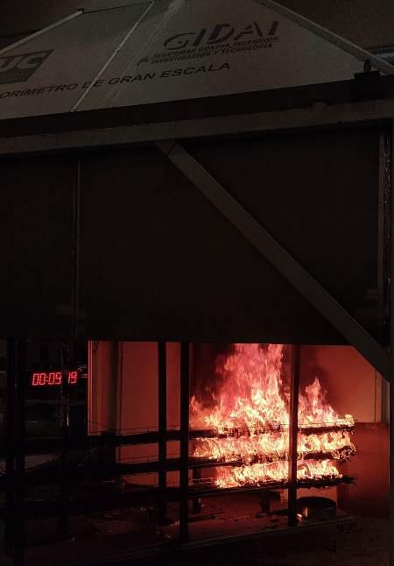
Figure 1: Identification of the figure 1

5. CONCLUSIONS

The extended abstracts shall be provided with a section of the main conclusions of the work presented. This section should be clear and concise.

6. AKNOWLEDGMENTS

The acknowledgements should be done in a separate section at the end of the text and before the references.

7. REFERENCES

The references should be cited in the text by Arabic numerals between brackets (for example 1). Their numbering must be sequential and according to the order of citation in the text.

All references must include the last name and initials of the author (s), article title (in quotes), title of publication (in italics), volume, year of publication and number of pages.

See the example below: [1] – book, [2] – report, [3] – journal paper; [4] –conference paper; [5] – Thesis.

When references have three or more authors, indicate the first author et al.. The numbering of the references should be placed in parentheses straight and aligned to the left. The text should be indented 7,5mm from the left margin.

References to websites are not permitted.

[1] Ballio, G.; Mazzolani, F.M. – Theory and Design of Steel Structures. Chapman and Hall, 1983, 632 p.
[2] Diederichs U., Jumppanen U. M. & Penttala V. - Behaviour of High-strength Concrete at High Temperatures, Tech. Report 92, Dept. of Struc. Engrg., Helsinki Univ. of Technology, Helsinki, 1989, 76 p.
[3] Khoury G. A., Sullivan P. J. E. & Grainger B. N. - Strain of Concrete During First Heating to 600ºC Under Load, Magazine of Concrete Research, vol. 37, no. 133, 1985, p. 195- 215.
[4] Taerwe, L. - Codes and Regulations, 4th International Symposium on Utilization of High-Strength / High-Performance Concrete, Paris, 1996, p. 93-99.
[5] Correia, A.J.M. – Fire Resistance of Building Columns With Restrained Thermal Elongation, Phd Thesis, University of Coimbra, 2008, 500 p.

Autor correspondente – GIDAI Group, University of Cantabria. Ave. Los Castros s/n, 39005 Santander (Spain). Telef.: +34 942 201826, Fax: +34 942 202276, E-mail: lazarom@unican.es

